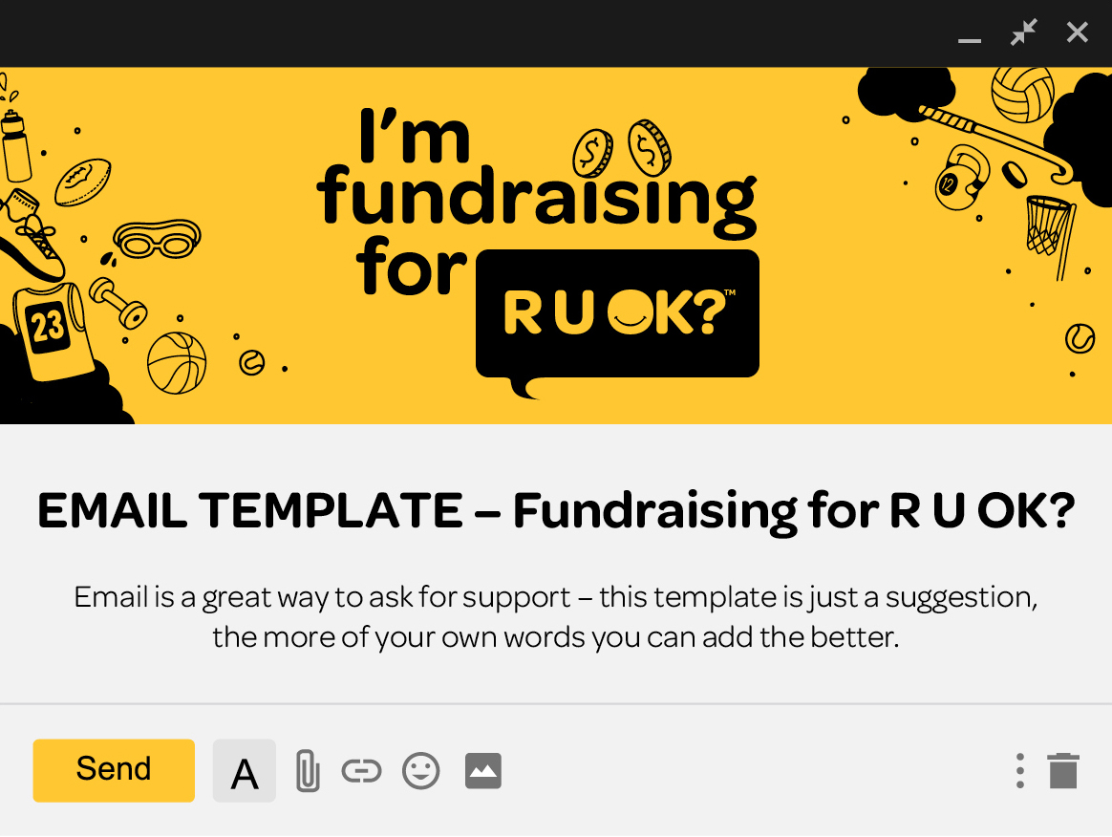

STEP 1.

Subject line!
Please Support My Efforts For R U OK? or
Please Sponsor Me as I Fundraise for R U OK?

STEP 2.

Copy and paste the below (change to if you want to get more personal!)

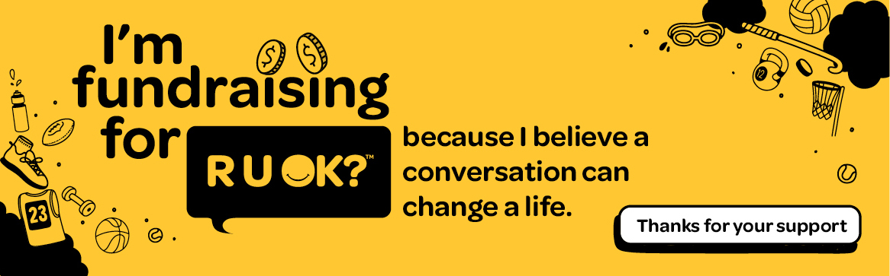

Hi [friend’s name],

I’ve decided to fundraise for R U OK? They are close to my heart, and I believe in their message and the work they do.

I’d love you to sponsor me - [copy and paste the link to your Fundraising Page].

I appreciate every donation, and they all help R U OK? bring us closer to a world where we are all connected and protected from suicide.
Thank you so much for your support.

Best wishes,
[your name]

By inspiring people to take the time to ask, ‘Are you OK?’ and listen, we can help people struggling with life to feel connected long before they even think about suicide.
#RUOKfundraiser

